<https://cleartax.in/paytax/TaxCalculator>

<https://www.bankbazaar.com/saving-schemes/nsc-vs-elss.html>

<https://www.fundsindia.com/content/jsp/LP/ELSS_landingPage/Elss_TaxSaver.jsp?gclid=CjwKCAjwzY2bBhB6EiwAPpUpZvPH62JxN4GKCDA-EBaqFTQG2iCzFi-H6lwvvgeyNN1Tk38Z-7XoJBoCu24QAvD_BwE&ef_id=Y0eynAAAALUlIAN-:20221103154251:s>

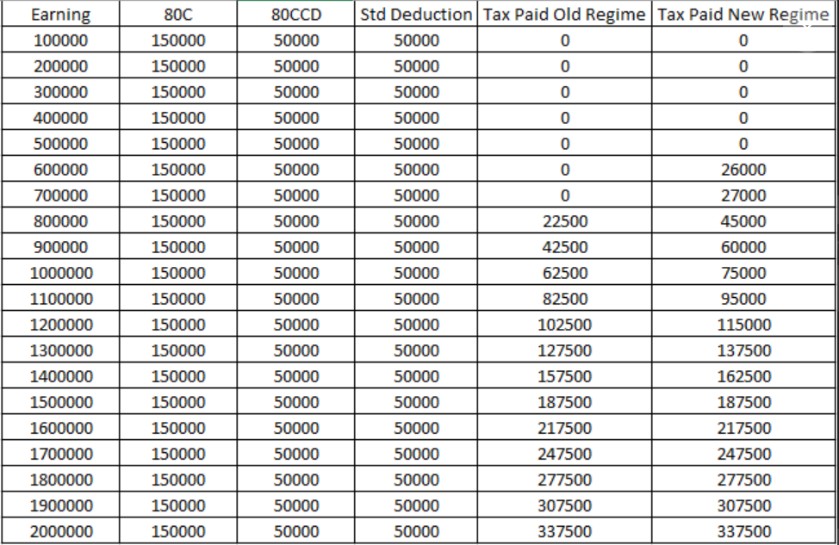

Income Tax Deductions

The following are the various deductions that can be claimed to help reduce one’s taxable income:

* **Section 80C:** A deduction of up to Rs. 1,50,000 can be claimed from the total income. Popular investments eligible for this tax deduction are payments made towards i) life insurance policies ii) superannuation/provident fund iii) equity-linked savings scheme and iv) certain post-office schemes such as Sukanya Samriddhi Yojana.
* **Section 80CCC:** A deduction of up to Rs. 1,50,000 can be claimed from the total income for contribution to certain pension funds.
* **Section 80CCD:** A deduction of up to Rs. 1,50,000 can be claimed from the total income for contributions to pension schemes notified by the Central Government.

*Note:* Section 80CCD Part (1B) provides an added deduction of Rs. 50,000 for contribution made under National Pension Scheme. While the maximum deduction as an aggregate of the three Sections mentioned above should not exceed Rs. 1,50,000, but, after including Section 80CCD(1B), the total deduction limit comes to Rs. 2,00,000.

* **Section 80D:** A deduction of up to Rs. 1,00,000 can be claimed for expenses incurred towards medical insurance.
* **Section 80DDB:** A deduction of up to Rs. 40,000 (Rs. 1,00,000 for senior citizens and for super senior citizens) can be claimed for medical expenses incurred to treat certain diseases.
* **Section 80E:** Tax deduction can be claimed on the interest part of the EMI paid towards an education loan during a financial year. There is no limit on the maximum amount that can be claimed as deduction.
* **Section 80EE:** Tax deduction can be claimed under Section 80EE on the interest payable on home loan (for first-time home buyers). The deduction shall be the interest amount or Rs. 50,000, whichever is lesser.
* **Section 80RRB:** Those who receive an income as royalty can claim deduction for royalty income earned or Rs. 3,00,000, whichever is lesser.
* **Section 80TTA:** A deduction of Rs. 10,000 can be claimed on interest income from savings account with a i) bank ii) co-operative society carrying on the business of banking and iii) post office.
* **Section 80U:** An individual who has been certified as a person with disability can claim tax benefit under this Section. Deduction of Rs. 75,000 is allowed for people with disabilities and Rs. 1,25,000 for those with severe disability.
* **Section 24:** Individuals owning a home can claim tax deduction of up to Rs. 2,00,000 on the home loan interest if the owner or his or her family is residing in the house property.

Budget 2018: Changes Brought About in Income Tax Rules

* The finance minister has raised cess on personal income tax to 4% from 3%.
* A standard deduction of Rs. 40,000 has replaced deductions of Rs. 19,200 for transport allowance and Rs. 15,000 for medical reimbursement.
* The threshold for TDS on interest income for senior citizens hiked to Rs. 50,000 from Rs. 10,000.
* The government has proposed extending the tax-free withdrawal benefit from National Pension System to all of its subscribers – both employees as well as non-employees.
* Tax deduction for health insurance premiums paid for senior citizens raised to Rs. 50,000 from Rs. 30,000.